

Setting Non-Nettable inventory status

MFG/ Pro v.9

Table of Contents
Objective 3
Process Steps 3
Inventory Status Code Report/ Maintenance: 1.1.3 / 1.1.1 3
Location Maintenance 1.1.18 4

Objective

The purpose of this instruction is to change Inventory status for the location to non-nettable (NN).
Non-nettable stock is not considered for MRP calculation

Process Steps

Inventory Status Code Report/ Maintenance: 1.1.3 / 1.1.1
In this program you can review what existing Inventory Statuses have NN status
Here you can see all the available statuses. You can choose status base on:
- Available (can be used for shipping or manufacturing/ non-defect materials)
- Nettable (included in MRP)
- Overissue (can go negative)
- Restricted transactions (If there are any transaction not allowed for the inventory status)
The most common non-nettable status in NN
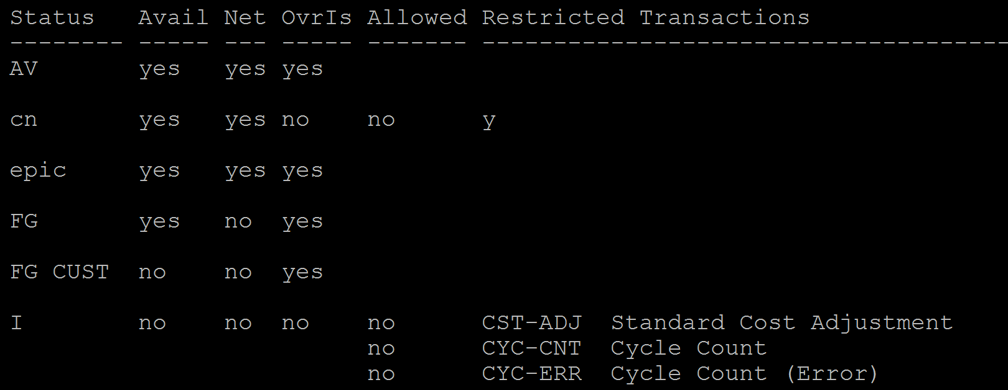
If you can’t find proper non-nettable status – you can create it using a program 1.1.1 - Inventory Status Code Maint.
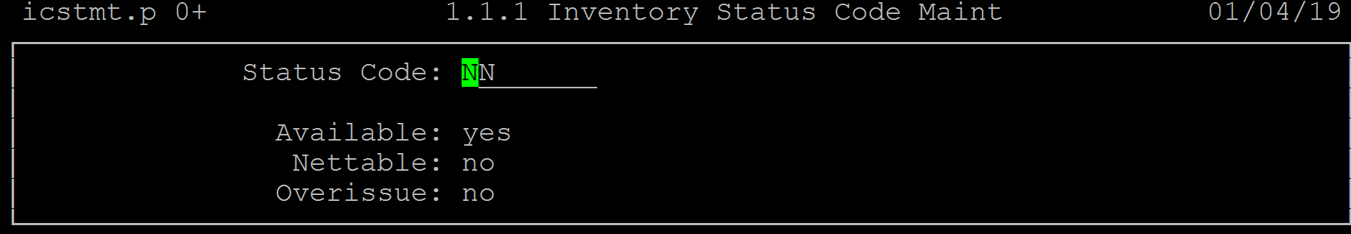

Location Maintenance 1.1.18
In this menu you assign Inventory Status of your choice to a specific location:

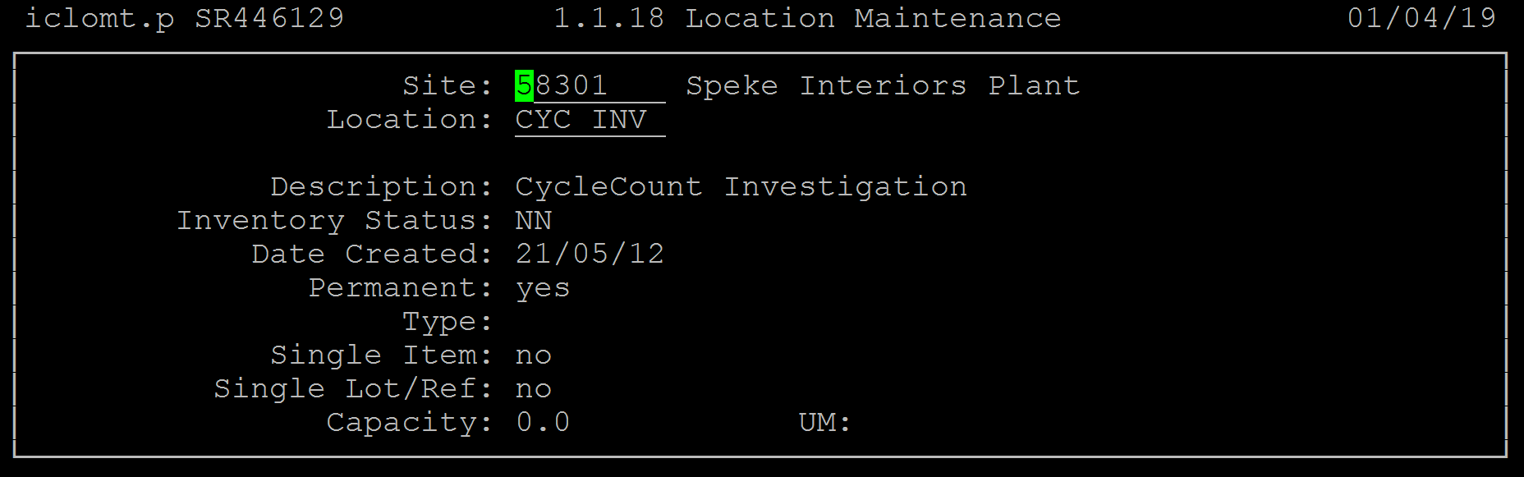

Please note that current inventory at the location will not be changed.
Only new inventory at the location will get a new status.
To deal with it you can use this program 3.4.2 – Transfer Multi Item to move material to a Dummy location and then move it back:
